LEAD & COPPER INVENTORY FORM

Please completely fill out this form. If you are not sure how to answer one of the questions, or fill in one of the blanks, scroll below the form for more information on service line types, and how and where to identify them, as well as many other frequently asked questions. Russell County PSA greatly appreciates your assistance with this project.

Instructions: Customers will need to visually inspect their service lines. This can be done by looking at the plumbing under your home, under your sink, and/or removing the meter lid where your service line connects to the PSA water meter.

First name
Last name
Account Number
Email (Optional) _________________________________
What type of Service Line do you have? Select ONE
Non-Lead
Galvanized
Lead
Unknown
-See bottom page for help identifying what type of Service Line you have
If you selected Non-Lead, what material is your Service Line?
What year was your home built
What year was your service line installed?
Street Address
City
Postal / Zip code
Additional Comments (Optional)
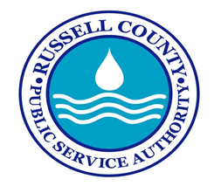

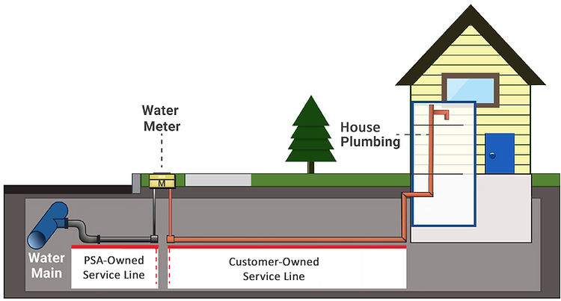

Customers will need to inspect their service lines, shown above in orange. Russell Co PSA will inspect all authority owned lines.

Identifying The Type of Service Line You Have

Service lines will need to be identified as:
​
Lead - A known lead service line, which can be verified by one of the methods below.
Galvanized - A line know NOT to be lead, which can be verified by one of the methods below.
Non-Lead - Any service line that is plastic (PVC, CPVC), copper, or any other line determined not to be lead or galvanized.
Unknown - A service line material that is not known to be lead, galvanized, or non- lead. If you encounter this issue, please contact our office at 276-991-0200.

